Progress award and 252 award scheme qualifying scores
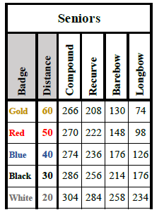

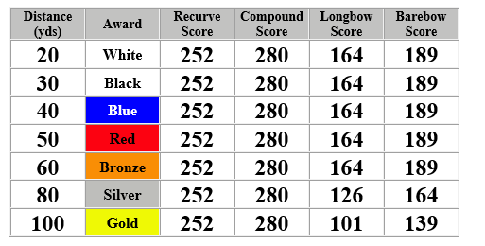

You will require two qualifying scoresheets for the 252 award scheme and you will require three qualifying scores for the Progress award – both can be run consecutively (only three score sheets need to be submitted) as long as the qualifying scores are achieved – so please take note of the slight differences for each distance in the Progress award.
