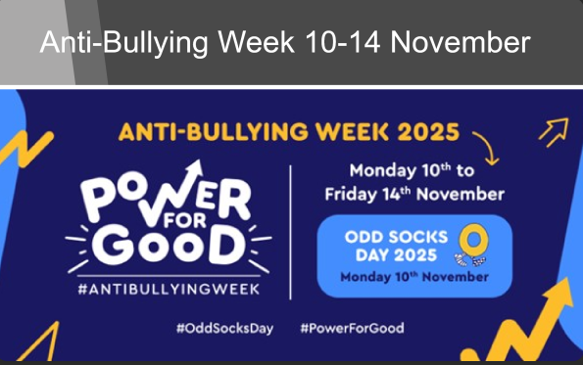

The theme for this year’s Anti-Bullying Week is Power for Good, which is about empowering children and young people to use their Power for Good to speak out, support others, and build a world where kindness wins.
The awareness campaign kicks off on Monday 10 November with Odd Socks Day, a simple way to show support for the campaign by wearing odd socks. Click on the link to access resources available from the Anti-Bullying Alliance.
Scotland supports Anti-Bullying Week through their 'Respect Me' anti-bullying service.
Page 5 of Archery GB's 'What is abuse?' provides guidance on bullying.

